**Mod 2: Critical Thinking**

Alex Mehler

CSU Global

CSC450-1

Dr. Bindu George

June 1, 2024

**Execution:**

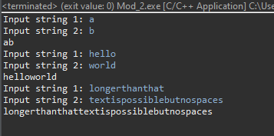

**Code:**

**#include**<iostream>

//Standard namespace declaration

**using** **namespace** std;

//Main Function

**int** **main**()

{

**string** input1;

**string** input2;

**string** combo;

**int** i;

**for** (i=0; i<3; i++){

cout << "Input string 1: ";

cin >> input1;

cout << "Input string 2: ";

cin >> input2;

input1.append(input2);

cout << input1 << "\n";

}

}

**Git:**

https://github.com/SevRnce/c_mod_2